GALAPAGOS ONBOARD A CRUISE
6 DAYS / 5 NIGHTS CATAMARAN ECOGALAXY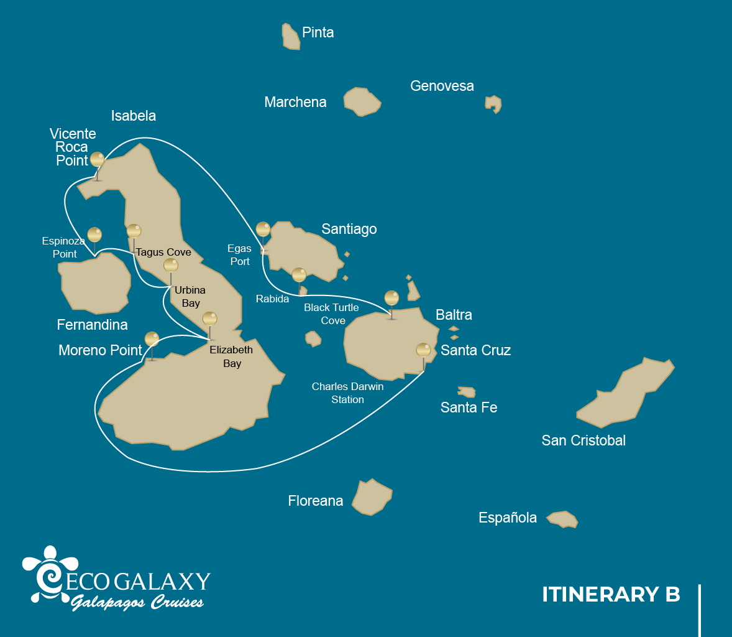
 |  |  |  | HIKING | SNORKEL | PANGA RIDE | PADDLE BOARD | KAYAK
6 DAYS CRUISE ITINERARY "B" | SATURDAY | PM | Santa Cruz: Charles Darwin Station | •
 | SUNDAY | AM | Isabela: Moreno Point | • | • | •
 |  | PM | Isabela: Elizabeth Bay |  |  | •
 | MONDAY | AM | Isabela: Urbina Bay | • | •
 |  | PM | Isabela: Tagus Cove | • | • | • | • | •
 | TUESDAY | AM | Fernandina : Espinoza Point | • | •
 |  | PM | Isabela: Vicente Roca Point |  | • | •
 | WEDNESDAY | AM | Santiago: Egas Port | • | •
 |  | PM | Rabida: Rabida | • | • | • | • | •
 | THURSDAY | AM | Santa Cruz: Black Turtle Cove |  |  | •

DAY 1- SATURDAY / - Santa Cruz: Charles Darwin Station
AM: BALTRA AIRPORT
Departure to the Galapagos Islands, arrival at Baltra airport, where our naturalist guide of the National Park will be waiting for you.
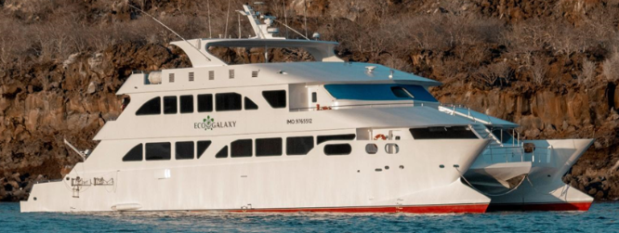
PM: CHARLES DARWIN STATION
The Charles Darwin Station is a nonprofit organization which has been working for decades together with the Galapagos National Park to preserve the biodiversity of these unique islands. During this visit you will learn about the projects that both institutions carry together to protect the native species and eradicate the invasive ones which are threatening the Galapagos environment. One of the most important and emblematic projects has been reproducing giant tortoises in captivity. The visit is mostly outdoors in a beautiful dry native forest with giant cactus and many other interesting native plants. It is also a fantastic place to find several endemic Darwin finches, as well as flycatchers and mockingbirds.
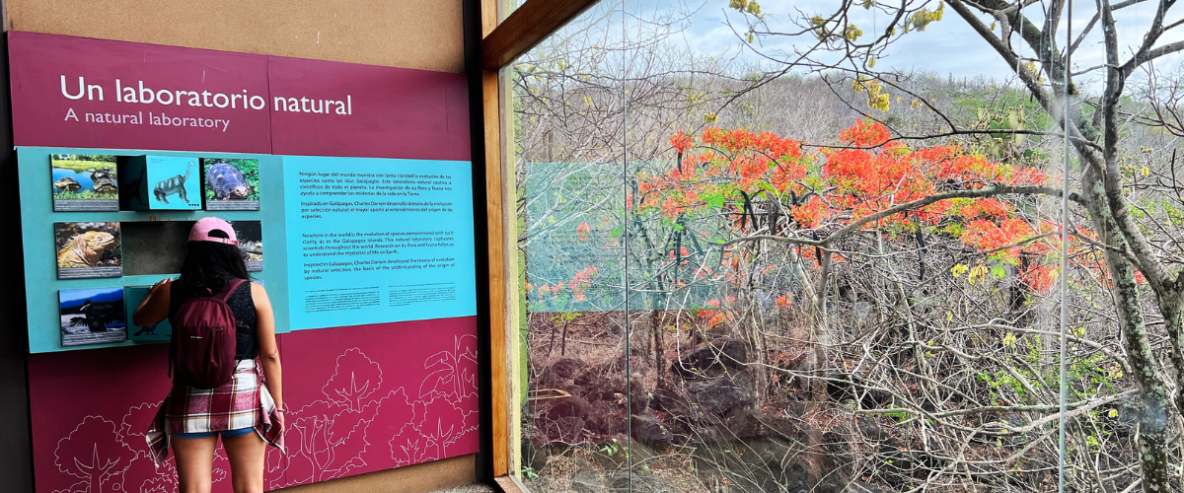
Highlights: Galapagos giant tortoise & land iguanas breeding program, Darwin finches, Galapagos mockingbirds, Galapagos flycatchers, yellow warblers.
Trail | 2 km / 1,2 mi
Level | 1
Activities | Dry landing and hiking

Day 2- SUNDAY/ - MORENO POINT - ELIZABETH BAY
AM: MORENO POINT
Moreno Point is a magical place with extensive lava fields which look lifeless at first sight. Once inland, scattered brackish lagoons form an oasis of life where you can find flamingoes, gallinules, ducks and herons. Along the shore we will look for penguins, marine iguanas, flightless cormorants, blue-footed boobies, sea lions, oystercatchers and other shore birds.
Snorkel: We will snorkel to see sea turtles, cormorants and many species of fish. Look carefully in the long seaweeds and you might find a seahorse.
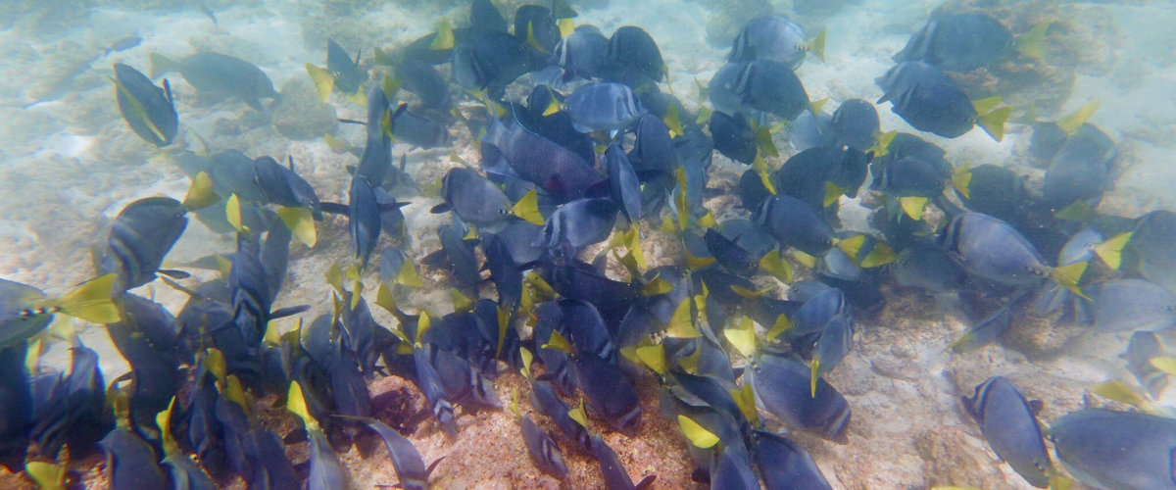
Highlights: American flamingoes, ducks, gallinules, penguins, cormorants, marine iguanas, sea lions, Galapagos mockingbirds, Darwin finches.
Trail | 1,6 km / 1 mi
Level | 3
Activities | Dry landing and hiking

PM: ELIZABETH BAY
Elizabeth Bay is a beautiful sheltered bay surrounded by large mangroves and barren lava fields. There is no trail here so you will take a dinghy tour to explore many channels, pools and coves teeming with life. This is one of the best locations in the islands to see Galapagos penguins, but don’t expect to see thousands of them, as the entire population of the islands is only about 3.000 of them. Flightless cormorants also nest in the area and blue-footed boobies and pelicans often fish in these shallow and rich waters. Rays and sea turtles are also very abundant.
Highlights: Galapagos hawks, sea turtles, rays, Galapagos penguins, flightless cormorants, herons.
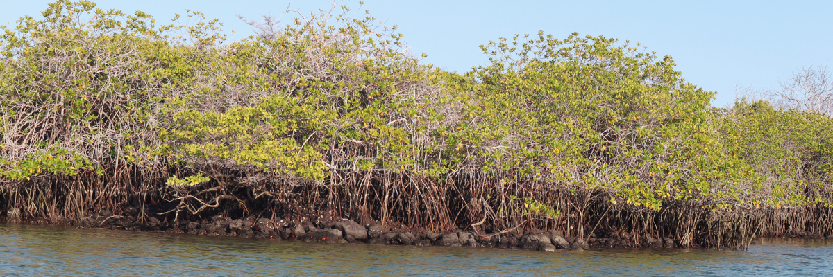
Meals | B/L/D
Level | 1
Activities | Panga Ride

DAY 3 - MONDAY/ - URBINA BAY/ TAGUS COVE
AM: URBINA BAY
This place is known for the dramatic uplifting that happened here during the 1950’s. A large portion of the coast was pushed up, exposing many hectares of previously submerged land. Look carefully along the trail and you will find small shells and corals, a proof that the area was underwater more than sixty years ago. The trail will give the opportunity to see land iguanas and, during certain seasons, giant tortoises. Galapagos hawks nest in the area and are often seen flying or perched on the trees.
Snorkel: You can snorkel from the beach to see sea turtles, cormorants and penguins. Fish are also abundant in the area.
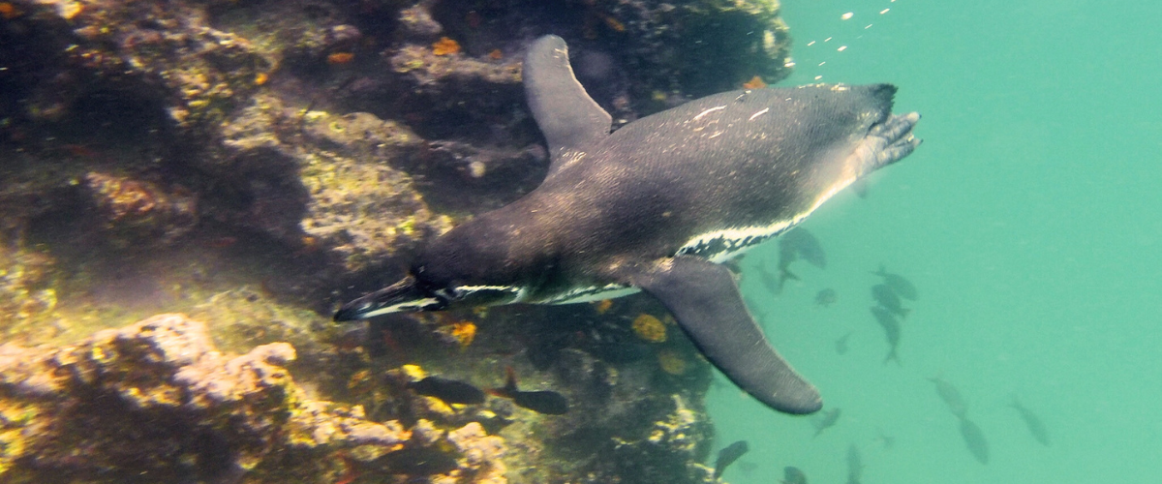
Highlights: Galapagos hawks, land iguanas, Galapagos hawks, Galapagos mockingbirds, Darwin finches, flycatchers.
Trail | 1,2 km / 0,7 mi. Long Trail: 3,0 km / 1,8 mi
Level | 1
Activities | Wet landing and hiking

PM: TAGUS COVE
Tagus cove is one of the places Charles Darwin visited during his exploration of the Galapagos islands. A trail will take you through the dry Palo Santo forests where you can see Darwin finches and mockingbirds. You will get great views of Darwin’s lake and the large volcanos of northern Isabela.
A boat tour along the shore will give you chances to see penguins, cormorants, marine iguanas and a very unique species: the Galapagos martin, a small endemic bird which is one of the most endangered species on the island.
Snorkel: The nutrient-rich waters around Tagus Cove attract a lot of sea turtles and a great diversity of fish, but also penguins, who feast on large schools of anchovies. It is common to see cormorants underwater as they chase fish through the reef.
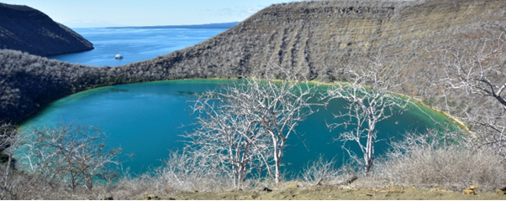
Highlights: Galapagos hawks, marine iguanas, flightless cormorants, herons, penguins, sea turtles, sea stars.
Trail | 2,6 km / 1,6 mi
Meals | B/L/D
Level | 3
Activities | Wet landing and hiking

DAY 4 -TUESDAY/- ESPINOZA POINT / VICENTE ROCA POINT
AM: ESPINOZA POINT
Located at the base of an imposing volcano (the most active in the Galapagos islands) this site is one of the jewels of the Galapagos National Park. As soon as you disembark you will be surrounded by hundreds of marine iguanas, as this is the largest colony for the species. Sea lions bask in the beaches while their pups play in tide pools. Along the shore you will see flightless cormorants, which are restricted to the western areas of the archipelago. Surrounded by cold plankton-rich waters, Punta Espinosa is home for an array of species, including herons, pelicans, oystercatchers, sea turtles, shorebird and many more. Look up in the mangroves as Galapagos hawks often perch to look for their prey.
Snorkel: The nutrient-rich waters around Punta Espinosa attracts great numbers and diversity of fish and sea turtles. Seaweeds are also abundant, making this place the best for seeing marine iguanas feeding underwater. Following a cormorant underwater as it chases fish through the reef is one of the most amazing snorkel experiences you may have on your trip.
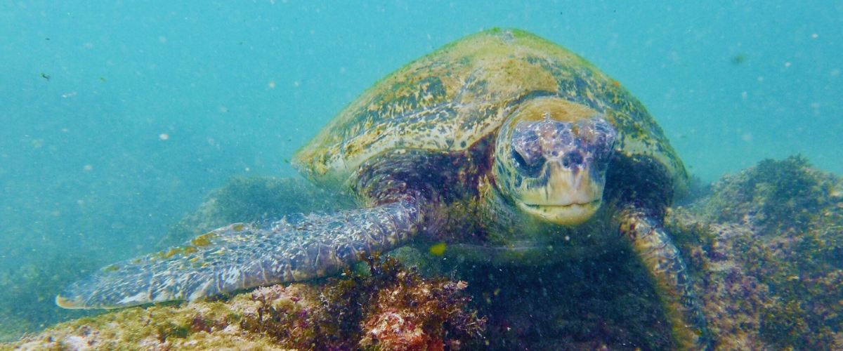
Highlights: Galapagos hawks, marine iguanas, flightless cormorants, penguins, sea turtles, sea lions, herons, oystercatchers, shorebirds, sally light-foot crabs.
Trail | 1,6 km / 1 mi
Level | 2
Activities | Dry landing and hiking

PM: VICENTE ROCA POINT
Surrounded by some of the tallest cliffs in the Galapagos, Vicente Roca point is a great location to observe spectacular landscapes and interesting volcanic features. There is no trail here but you will take a dinghy tour along the shore to get a closer view of pelicans, flightless cormorants, sea turtles, boobies, Galapagos fur seals and marine iguanas. The area is also known to be a good location for whales and dolphins.
Snorkel: Snorkel in the cove to look for sea turtles, penguins, sea lions, cormorants, rays and many different species of fish. Look for fan corals, sponges and other invertebrates growing on the walls.
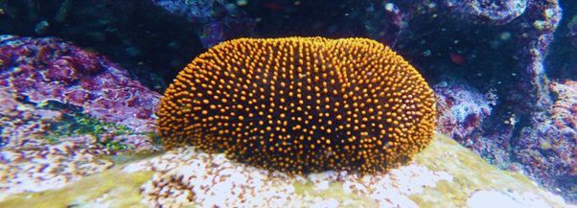Highlights: Marine iguanas, flightless cormorants, penguins, sea turtles, fur seals, Nazca & blue-footed boobies
Meals | B / L / D
Trail | 1,4 km / 0,8 mi
Level | 1
Activities | Panga ride

DAY 5 -WEDNESDAY / EGAS PORT - RABIDA
AM: EGAS PORT
Despite its name, there is no “port” at Puerto Egas, but you might see a few remains of the last attempts to colonize the island during the 60’s. The trail goes along the coastline which is rich in wildlife, with marine iguanas basking in the sun everywhere, Galapagos sea lions, herons, oystercatchers and many shorebirds. At the end of the trail an area called “the grottos” is home for a small colony of the endemic Galapagos fur seal, much more difficult to see at close range than its cousin. As recently as 2019, land iguanas where re-introduced to the area, so look around for these impressive reptiles which where extinct from Santiago for over a century.
Snorkel: You can snorkel from the beach and explore an area of rocky bottoms which is excellent for fish, turtles and reef sharks. Often, sea lions are also present and are happy to interact with divers.
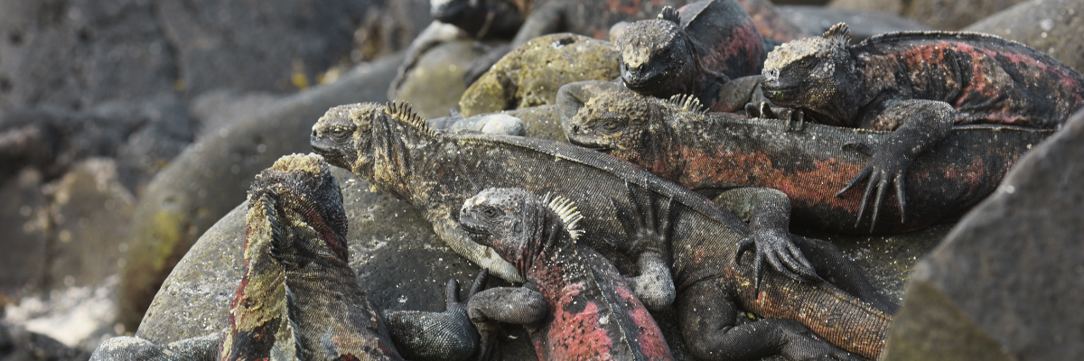
Highlights: Galapagos sea lions, Galapagos fur seals, oystercatchers, marine & land iguanas, Galapagos hawks, herons, shorebirds, Darwin finches, Galapagos doves.
Level | 1
Trail | 2,3 km / 1,4 mi
Activities | Wet landing and hiking

PM: RABIDA
Rabida is a small island famous for its reddish lava rocks (rich in iron) which gives it a unique look. The beach is also red and hosts a small colony of sea lions. There is a small salt water lagoon where we will see ducks and stilts and sometimes flamingoes. The trail will take you inland to get beautiful views of the beach and the lagoon. Look for Darwin finches, flycatchers and mockingbirds. In the cliffs along the coast you can find Nazca & blue-footed boobies, brown noddy, herons and the two species of sea lions: Galapagos and fur seals.
Snorkel: You can snorkel from the beach and explore a sheltered rocky area, which is excellent for fish, sea lions and reef sharks. Look at the high diversity of small invertebrates attached to the vertical walls.
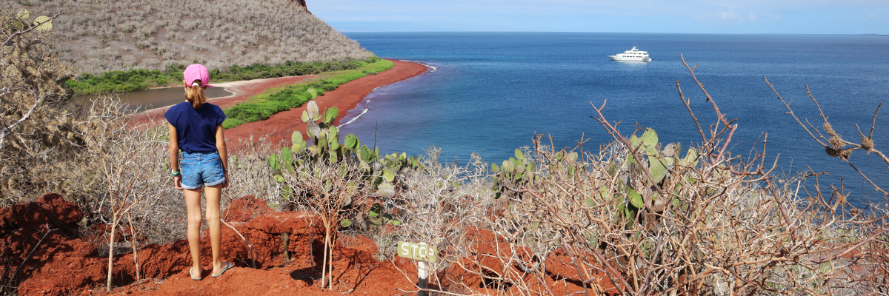
Highlights: Red-sand beach, Galapagos sea lions, Galapagos hawks, flycatchers, Darwin finches, Galapagos mockingbirds, ducks, flamingoes.
Trail | 2 km / 1,2 mi
Meals | B/L/D
Level | 1
Activities | Wet landing and hiking

DAY 6 -THURSDAY / BLACK TURTLE COVE
AM: BLACK TURTLE COVE
Black Turtle Cove gets its name from the abundance of green see turtles, locally known as: “tortugas negras”. There is no landing here so you will be doing a boat tour on the dinghies, exploring shallow channels and small coves surrounded by beautiful mangrove forests. Reef sharks, sea turtles and several species rays inhabit this beautiful area which is considered an important mating area for turtles and a nursery for several species of sharks. Herons, pelicans and boobies are also common here as they prey in schools of anchovies.
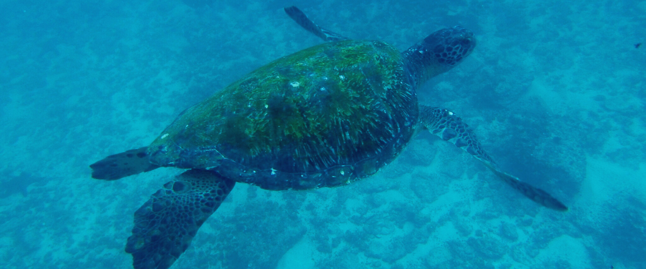
Highlights: White-tipped and black-tipped reef sharks, green see turtles, rays, herons, blue-footed boobies, mangroves.

Then, transfer to the airport to take your flight back to continental Ecuador.
Meals | B
Level | 1
Activities | Panga Ride

Glossary

Meals | Breakfast | B
 | Lunch | L
 | Dinner | D
Hiking Effort | Level 1 | Easy
 | Level 2 | Moderate
 | Level 3 | Hard

