GALAPAGOS ONBOARD A CRUISE
6 DAYS / 5 NIGHTS CATAMARAN ECOGALAXY
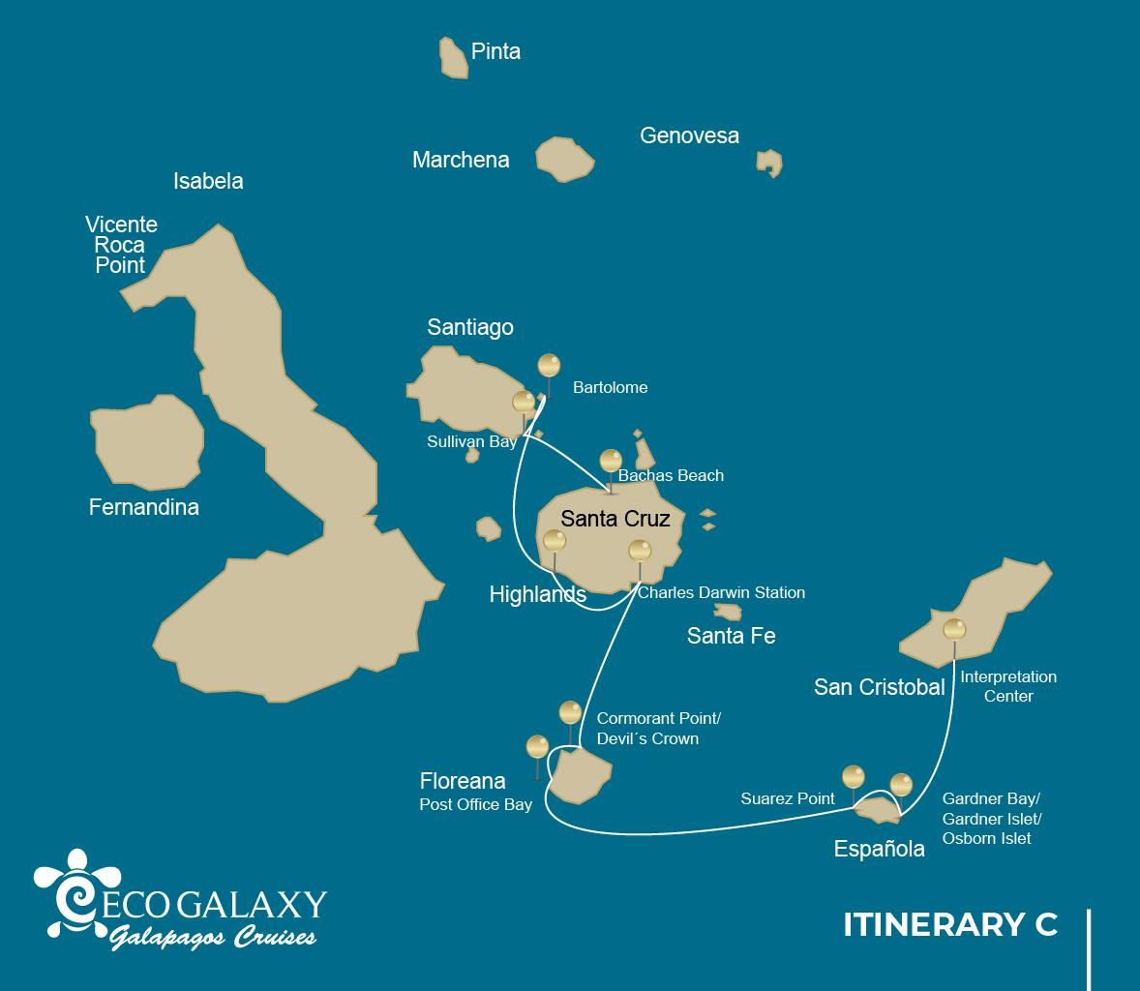
 |  |  |  | HIKING | SNORKEL | PANGA RIDE | PADDLE BOARD | KAYAK
6 DAYS CRUISE ITINERARY "C" | THURSDAY | PM | Santa Cruz: Bachas Beach | • | •
 | FRIDAY | AM | Santiago: Sullivan Bay | • | •
 |  | PM | Bartolome: Bartolome | • | • | •
 | SATURDAY | AM | Santa Cruz: Highland | •
 |  | PM | Santa Cruz: Charles Darwin Station | •
 | SUNDAY | AM | Floreana: Cormorant Point / Devil Crown | • | • | •
 |  | PM | Floreana: Post Office Bay | • | •
 | MONDAY | AM | Española: Suarez Point | •
 |  | PM | Española: Garnerd Bay / Islote Gardner/Osborn Islote | • | • | • | • | •
 | TUESDAY | AM | San Cristobal: Interpretation Center | •

DAY 1- THURSDAY / - BALTRA AIRPORT- BACHAS
AM: BALTRA AIRPORT
Departure to the Galapagos Islands, arrival at Baltra airport, where our naturalist guide of the National Park will be waiting for you.
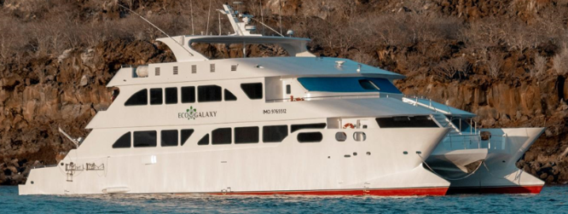
PM: BACHAS
Bachas gets its name from the remains of two large barges (mispronounced by locals as “bachas”) left by the Americans during WWII. At low tide you can still see the iron skeletons of the barges buried in the white sand. From November till May, this place is also one of the most important sea turtle nesting grounds in the entire Galapagos islands. There are also several small saltwater lagoons where we often see flamingoes, herons and other aquatic birds.
Snorkel: After the walk, you will have the option to swim or snorkel from the beach. The area is rich in some of the most common fish species of the Galapagos, but you can also find white-tipped reef sharks and rays.
Highlights: American flamingoes, white cheeked pintails, sandpipers, lava gulls, blue footed boobies.
Meals | L/B
Trail | 1,6 km / 1 mi
Level | 1
Activities | Wet landing and hiking

Day 2- SUNDAY/ - SULLIVAN BAY - BARTOLOME
AM: SULLIVAN BAY
This hike is a journey into understanding the birth of these volcanic islands. You will walk in a very well preserved flow of Pahoehoe lava, which will give you endless opportunities to see the delicate textures of these type of lavas which only appear in a few places throughout the world. At first sight the barren landscape looks completely deprived of life, but look carefully for pioneer plants, lava lizards and small birds. By the shore, you can find penguins, pelicans and oystercatchers.
Snorkel: You will have the option to swim or snorkel from a coral sand beach or from the dinghies. Getting underwater is like traveling to another world: if the land is almost lifeless, the sea is teaming with life, including large schools of fish, Galapagos penguins, reef sharks, turtles and rays.
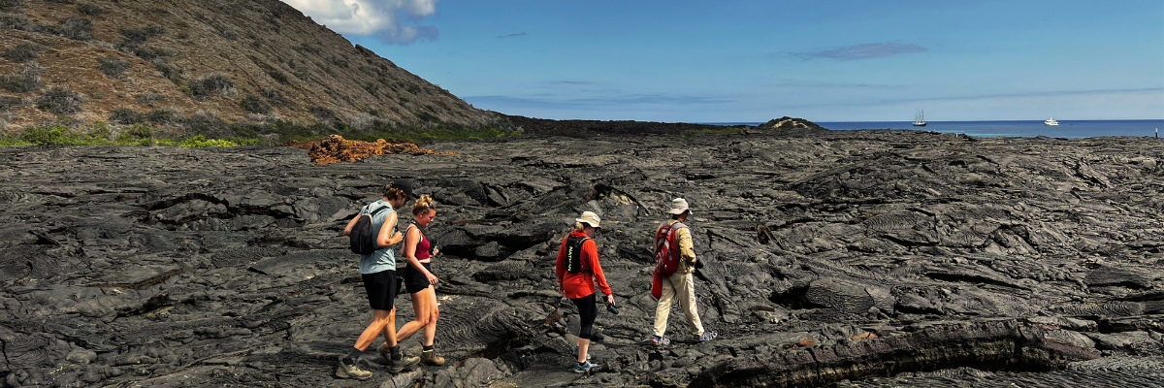
Highlights: Pahoehoe lava, Galapagos penguins, oystercatchers, Galapagos hawks.
Trail | 2,2 km / 1,4 mi
Level | 3
Activities | Dry landing and hiking

PM: BARTOLOME
Bartolome is one of the most iconic places in the Galapagos and one of the few where you can see penguins without going to the remote areas of western Isabela and Fernandina. You will get great views of Pinnacle Rock, located in the northern side of the island, right next to a beautiful peach-color sand beach.
The hike to the top of the island is fantastic and will offer you incredible views of lunar landscapes with scattered volcanic cones. Many islands are visible from this outlook, as well as the bay of Sullivan and the Pinnacle rock.
Snorkel: You will have the option to swim or snorkel from the beach. This area holds a well-deserved reputation of being one of the best snorkeling places in the Galapagos, not only because it’s clear and calm water, but also because of the presence of penguins, which are relatively easy to find while snorkeling, along with an incredible diversity of fish, colorful invertebrates, sea lions, turtles, rays and reef sharks.
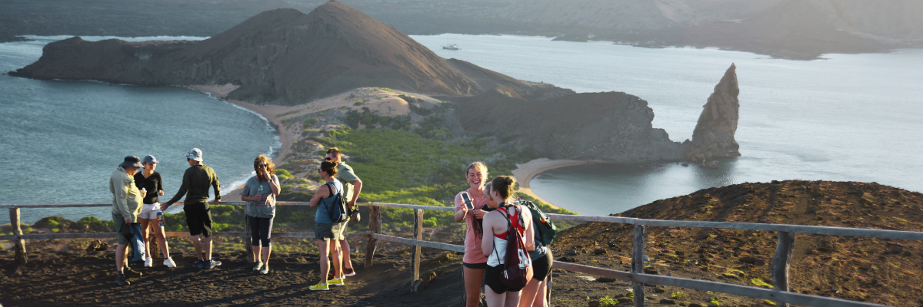
Highlights: Galapagos penguins, volcanic landscapes, Pinnacle rock, blue- footed boobies, herons, sea lions, sharks.
Meals | B / L / D
Trail | 1,5 km / 0,9 mi
Level | 2
Activities | Dry landing and hiking

DAY 3 - MONDAY/ - HIGHLANDS / CHARLES DARWIN STATION
AM: HIGHLANDS
Either if you do this visit starting from Baltra or from Puerto Ayora, a bus will take you to the highlands stopping along the way at one of the reserves to visit the lush highland forests where you will look for Galapagos Giant tortoises in their natural environment. This is the best place in the Galapagos to see these gentle giants (reaching over 300 kg / 600 pounds!) casually grazing and resting in freshwater ponds. This is also home for a great diversity of birds rarely found at the lowlands, including finches (tree, woodpecker and vegetarian finches), flycatchers and several species of water birds. You will visit a lava tunnel (depend on the itinerary) and learn how these extraordinary formations where created by ancient volcanic eruptions.
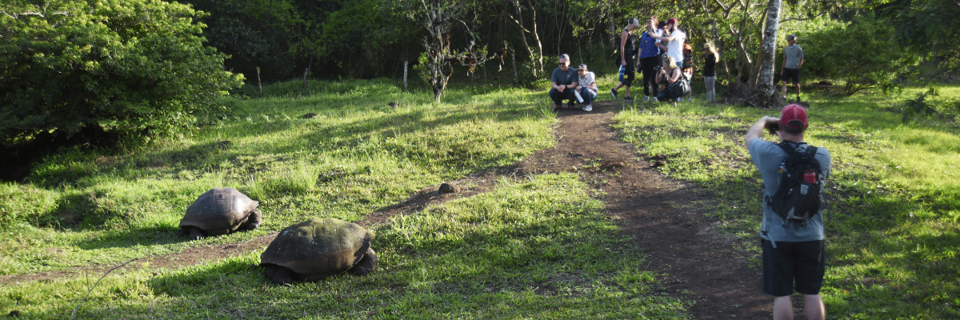
Highlights: Giant tortoises, Darwin finches, barn owls, white-cheeked pintails, Galapagos flycatchers, Lava tunnels.
Trail | 1 - 1,5 km / 0,6 – 0,9 mi
Level | 1
Activities | Dry landing and hiking

PM: CHARLES DARWIN STATION
The Charles Darwin Station is a nonprofit organization which has been working for decades together with the Galapagos National Park to preserve the biodiversity of these unique islands. During this visit you will learn about the projects that both institutions carry together to protect the native species and eradicate the invasive ones which are threatening the Galapagos environment. One of the most important and emblematic projects has been reproducing giant tortoises in captivity. The visit is mostly outdoors in a beautiful dry native forest with giant cactus and many other interesting native plants. It is also a fantastic place to find several endemic Darwin finches, as well as flycatchers and mockingbirds.

Highlights: Galapagos giant tortoise & land iguanas breeding program, Darwin finches, Galapagos mockingbirds, Galapagos flycatchers, yellow warblers.
Meal | B/L/D
Trail | 2 km / 1,2 mi
Level | 1
Activities | Dry landing and hiking

DAY 4 -TUESDAY/- CORMORANT POINT / DEVIL´S CROWN / POST OFFICE BAY
AM: CORMORANT POINT / DEVIL´S CROWN
Punta Cormorant is located in the north of Floreana and it is known for its large coastal lagoon with American flamingoes, white-cheeked pintails, black-necked stilts and other shorebirds. There is a beautiful white sand beach which is an important nesting ground for green sea turtles where we can also see rays and reef sharks. In the last years, a small groups of blue footed boobies have started to breed right by the trail. This is also a great trail to look at endemic plants.
Snorkel: It will be done at Devil’s Crown, a heavily eroded little volcano right by Floreana island. This is considered by many as one of the best snorkeling sites in the entire archipelago as the current funnels plankton through the Crown, attracting huge schools of snapper, Creole fish parrot fish, angelfish, reef sharks, sea turtles, rays and a phenomenal amount of marine life.
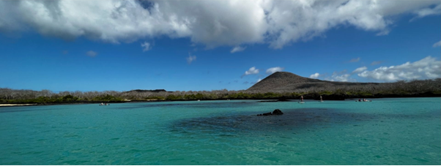
Highlights: American flamingo, blue-footed booby, frigatebirds, tropicbirds, Galapagos shearwaters, sea lions, sea turtle nesting site, finches, shorebirds, coral-sand beach.
Trail | 1,6 km / 1 mi
Level | 1
Activities | Wet landing and hiking

PM: POST OFFICE BAY
Floreana is famous for the tales of German settlers and the baroness during the late 1920’s and 30 ‘s. Assassinations, disappearances and other unsolved mysteries are the ingredients of this fascinating story.
Post office bay was often used by whalers to anchor their ships and go up to the highlands to get freshwater and tortoises. Most boats visiting the Galapagos had to came to this place sooner or later, so a system of mail was established more than 200 years ago: a barrel near the beach became the way to leave messages to other ships and also to the outside world. This mail system is still in use and will allow you to send postcards from the Galapagos to the outside world.
Aside from a small beautiful beach and a lava tunnel, the area is great for dinghy tours to look for sea lions, green sea turtles, shorebirds, small sharks and, with some luck, Galapagos penguins.
Snorkel: There is great snorkel from the beach, as you can see lots of sea turtles, rays, great diversity of fish and, if you are really lucky, Galapagos penguin,
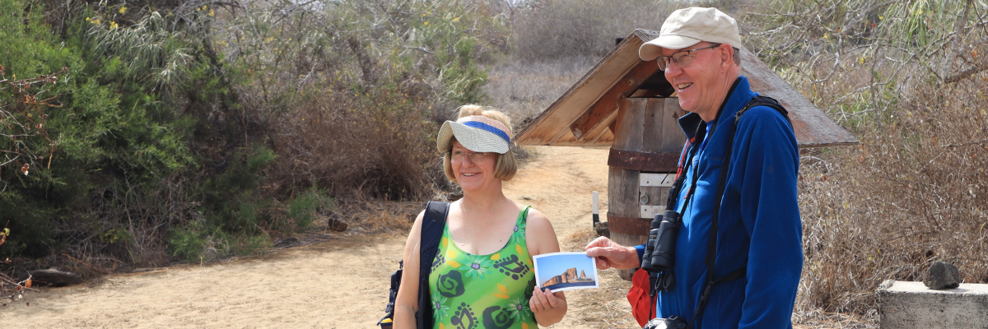
Highlights: Sea Lions, sea turtles, finches, shorebirds, marine iguanas, penguins.
Meals included | Breakfast, Lunch, and Dinner
Trail | 0,7 km / 0,4 mi
Level | 1
Activities | Wet landing and hiking

DAY 5 -WEDNESDAY / SUAREZ POINT/ GARDNER BAY
AM: SUAREZ POINT
The Suarez Point itinerary has been changed since September 20, 2023, due to a contingency conservation plan for the species on this island. By the authorization of the Galapagos National Park, only a 360-degree panga tour around the island will be allowed.
This itinerary will return to normal once the Galapagos National Park deems it optimal for welcoming guests again.
This rocky trail is one the most amazing nature walks you can do in the Galapagos islands.
From the moment you set foot on the island and all the way along the trail the amount and diversity of fauna is truly amazing. Sea lions and marine iguanas will be the first ones welcoming us, followed by large colonies of sea birds, including Nazca and Blue-footed boobies, gulls and tropicbirds. At the end of the trail we will visit a colony of waved albatross (April to January), the largest bird in the islands and one of the most interesting because of its powerful flight and elaborate courtship. Waved albatross only nest at Española, so this is the only place where you will see them at close range.
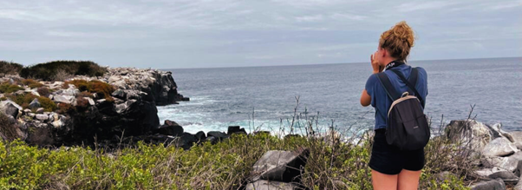Highlights: Sea lions, Waved Albatross, Galapagos hawks, Española mockingbirds, Darwin finches, marine iguanas, Nazca & Blue-footed Boobies, Red-billed Tropicbirds, Swallow-tailed gulls, herons, lava lizards, herons.
Trail | 1,7 km / 1,1 mi
Level | 3
Activities | Panga ride only.

PM: GARDNER BAY
Gardner beach is undoubtedly one of the most beautiful and interesting beaches to visit in the Galapagos. Its fine coral sand and turquoise water give it a totally tropical appearance, which contrasts with the presence of sea lions basking in the beach. You will have the opportunity to walk along the beach and learn about the biology of sea lions and other endemic species, such as the Española mockingbird, marine iguanas and Galapagos hawks.
Snorkel: There are several great snorkeling places at Gardner bay. It is a fantastic site to swim with sea lions, reef sharks, rays and many species of fish, including; Angelfish, Parrotfish, Damselfish, Surgeonfish and many others.
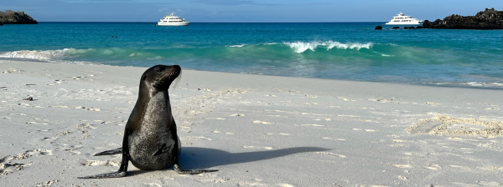Highlights: Coral sand beach, sea lions, Galapagos hawks, Española mockingbirds, Darwin finches, marine iguanas.
Meal | B/L/D
Trail | 0,8 km / 0,5 mi
Level | 1
Activities | Wet landing and hiking

DAY 6 -THURSDAY / INTERPRETATION CENTER
AM: INTERPRETATION CENTER
Located in the outskirts of Puerto Baquerizo, this center is dedicated to the history of human presence in the Galapagos. Since the times of the early Spanish explorers to the present times, including illustrious visitors such as Charles Darwin, this permanent exhibition will take you through the dangers and struggles of the first settlers trying to survive the harsh Galapagos environment.
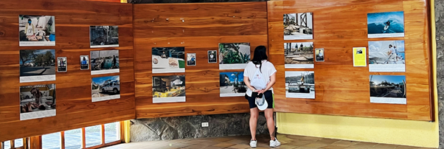
Highlights: Endemic plants, exhibition on human history
Trail | 0,2 km / 650 ft
Meals | B
Activities | Dry landing and hiking

Glossary

Meals | Breakfast | B
 | Lunch | L
 | Dinner | D
Hiking Effort | Level 1 | Easy
 | Level 2 | Moderate
 | Level 3 | Hard

